CPE /EE 556 A: Assignment five

Instructions
- upload one Microsoft text document that includes commented code for each part and YouTube links to the video demos.
- This assignment is out of 12 points.
- Please follow the example video demo posted on Canvas.
- Important Note: Please do not use any of the revised pins. Otherwise, your board will stop working.

Using timer to create a delay | polling approach.
- Create a project that toggles the onboard LED at the 0.5 Hz.
- Use a general-purpose timer to create the delay. The LED pin should not be connected to any of the timer’s channels. The timer is only used to generate the delay between the ON and OFF.
- The code should poll the UIF flag to check for counter overflow.
- The default system clock is 4 MHz.

Using timer to create a delay | interrupt approach.
- Use timer interrupt to implement the requirements of Q1

Using a timer in capture mode
- For the project (9. Timer_Capture mode_toggle_polling_1) published on Canvas, the initial values of the PSC and ARR registers are key to have synchronization between the (button_press_counter) and the timer delay.
- If you try different values like PSC=4000-1 and ARR=1000-9, you will find that a quick click on the button would result in a high delay
- Can you figure out a simple procedure to align the (button_press_counter) with the timer?
Hint: create a watch window to monitor the (button_press_counter)
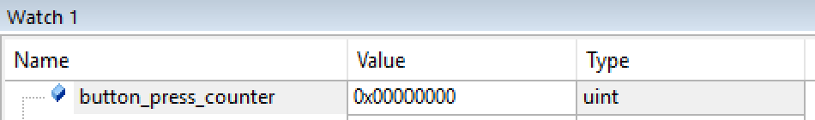
Make sure to comment this instruction
//button_press_counter=0; // reset button press counter
Otherwise the reading of the variable will be always zero. Also if you comment this step you need to reset the code after each run, otherwise the button_press_counter will keep building up.

Using timer in capture mode

The project (10. Timer_Capture mode_toggle_polling_2) has the same issue of desynchronization between the press hold counter and the delay generated by the timer.

What can be done to fix this issue?

B-U585I-IOT02A Discovery kit

Use one of the B-U585I-IOT02A Discovery kit’s timers to control the ON time duration of an LED according to the time duration at which the onboard push button is clicked.

